--рахує всю інфу про аккаунти

WITH account_details AS(

SELECT s.date,

sp.country,

a.send_interval,

a.is_verified,

a.is_unsubscribed,

COUNT(DISTINCT acs.account_id) AS account_cnt

FROM `DA.account_session` acs

JOIN `DA.account` a

ON a.id = acs.account_id

JOIN `DA.session_params` sp

ON acs.ga_session_id = sp.ga_session_id

JOIN `DA.session` s

ON acs.ga_session_id = s.ga_session_id

GROUP BY 1,2,3,4,5),

--рахує всю інфу о розсилках на емейл

email_details AS (

SELECT date_add(s.date, INTERVAL es.sent_date DAY) AS date,

sp.country,

a.is_verified,

a.is_unsubscribed,

a.send_interval,

COUNT(es.id_message) AS sent_msg,

COUNT(eo.id_message) AS open_msg,

COUNT(ev.id_message) AS visit_msg

FROM `DA.email_sent` es

LEFT JOIN `DA.email_open` eo

ON es.id_message = eo.id_message

LEFT JOIN `DA.email_visit` ev

ON es.id_message = ev.id_message

JOIN `DA.account_session` acs

ON es.id_account = acs.account_id

JOIN `DA.session` s

ON acs.ga_session_id = s.ga_session_id

JOIN `DA.session_params` sp

ON s.ga_session_id = sp.ga_session_id

JOIN `DA.account` a

ON acs.account_id = a.id

GROUP BY 1,2,3,4,5),

union_cte AS (

SELECT date,

country,

send_interval,

is_verified,

is_unsubscribed,

account_cnt,

0 AS sent_msg,

0 AS open_msg,

0 AS visit_msg

FROM account_details

union all

SELECT date,

country,

send_interval,

is_verified,

is_unsubscribed,

0 AS account_cnt,

sent_msg,

open_msg,

visit_msg

FROM email_details

),

--групування перших двух запитів та додавання window функцій

count_cte AS (

SELECT date,

country,

send_interval,

is_verified,

is_unsubscribed,

SUM(account_cnt) AS account_cnt,

SUM(sent_msg) AS sent_msg,

SUM(open_msg) AS open_msg,

SUM(visit_msg) AS visit_msg

FROM union_cte

GROUP BY 1,2,3,4,5),

-- створення кількісних віндоу функцій

window_cte AS(

SELECT date,

country,

send_interval,

is_verified,

is_unsubscribed,

account_cnt,

sent_msg,

open_msg,

visit_msg,

SUM(account_cnt) over(partition by country) AS total_country_account_cnt,

SUM(sent_msg) over(partition by country) AS total_country_sent_cnt,

FROM count_cte),

-- створення рангових віндоу функцій

rank_cte AS (

SELECT date,

country,

send_interval,

is_verified,

is_unsubscribed,

account_cnt,

sent_msg,

open_msg,

visit_msg,

total_country_account_cnt,

total_country_sent_cnt,

dense_rank() over(order by total_country_account_cnt desc) AS rank_total_country_account_cnt,

dense_rank() over( order by total_country_sent_cnt desc) AS rank_total_country_sent_cnt

FROM window_cte

)

-- кінцевий результат

SELECT date,

country,

send_interval,

is_verified,

is_unsubscribed,

account_cnt,

sent_msg,

open_msg,

visit_msg,

total_country_account_cnt,

total_country_sent_cnt,

rank_total_country_account_cnt,

rank_total_country_sent_cnt

FROM rank_cte

WHERE rank_total_country_account_cnt <=10 AND rank_total_country_sent_cnt <= 10

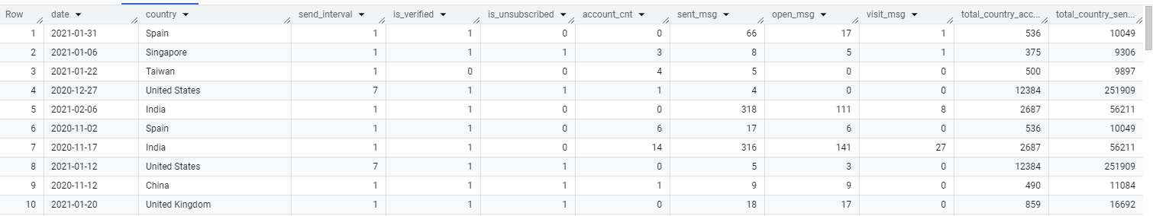

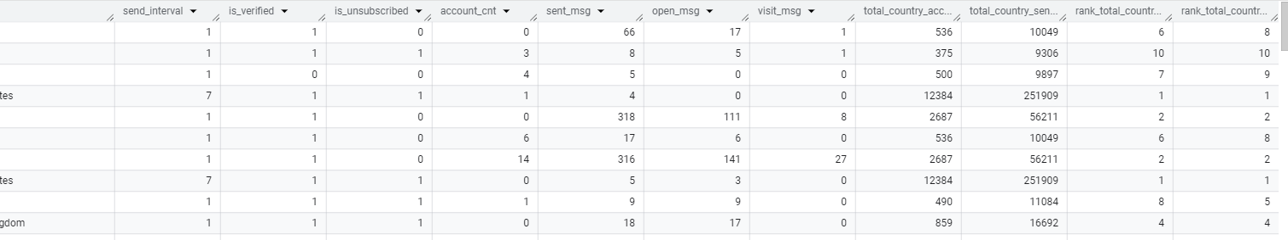

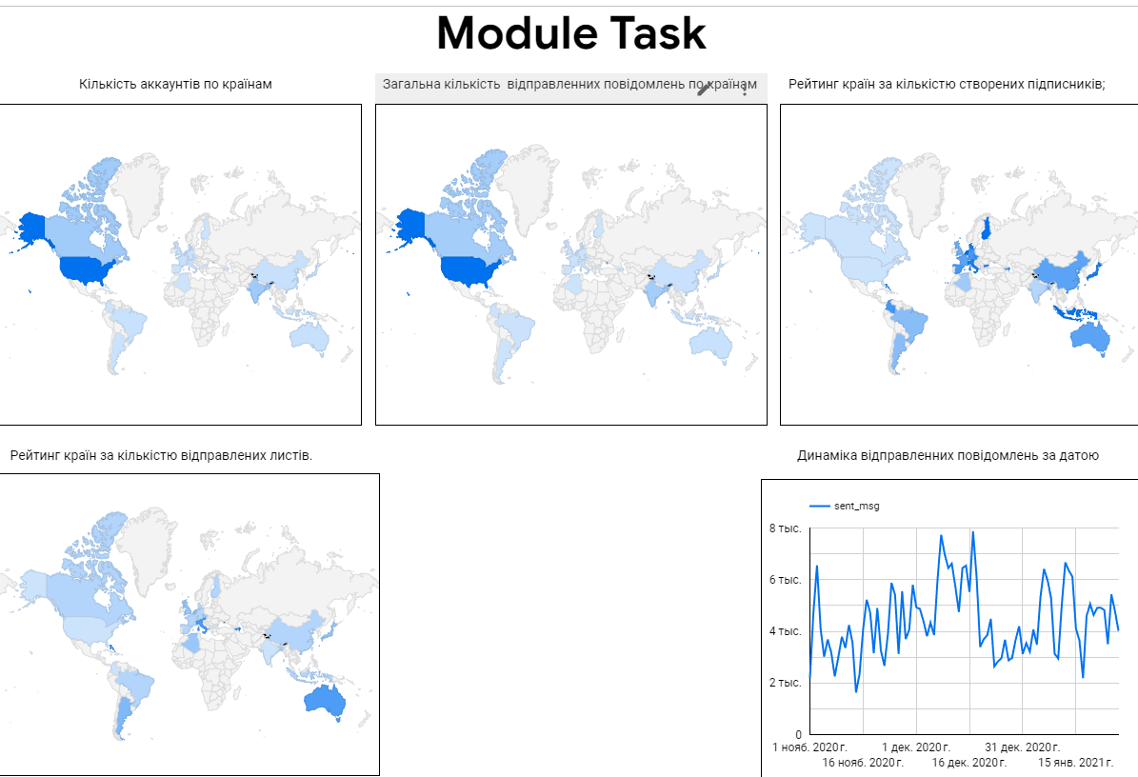

**Посилання на візуалізацію:  
https://lookerstudio.google.com/reporting/dd75f657-9b8d-4953-8fa3-25eb8c355046**